Demonstration –P-02-01 – 5 minutes
Linux File ACLs

This Demonstration will show students some of the built in access controls in the default Linux file system, and how to manipulate them.
The screen captures shown here have been taken from a Red Hat LINUX Version 9.0 system using a command line interface.
Here are the figures in this Demonstration:
Figure 1 - Making the /test directory 2
Figure 2 - Directory Listing 3
Figure 3 - Directory Listing after the Change 4
Figure 4 - Unsuccessful Directory Listing 5
Figure 5 - Successful Directory Listing 6

- On any Red Hat or other Linux system, open a terminal window (command shell).
- Login to the host as the root user.
- Once logged in to the system as the root user, create a new directory calls /test with the following command (as shown in Figure 1):
mkdir /test

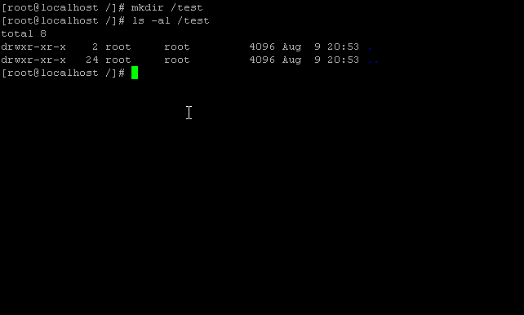
Figure 1 - Making the /test directory
- Once the directory has been created, list the contents of the / directory with the following command (the output will look similar to Figure 2)
ls –al /

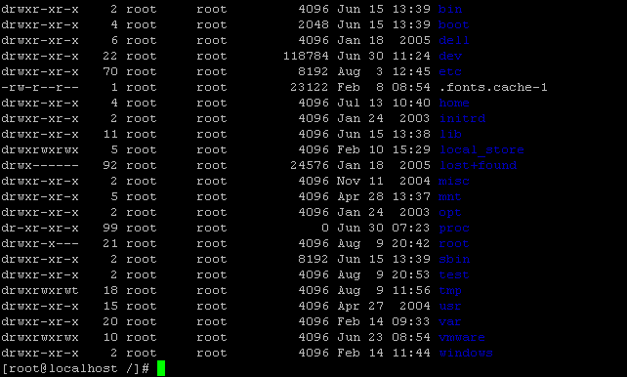
Figure 2 - Directory Listing
- Notice the set of characters to the left of the listing of files and directories on the right – the ones which start drwxr-xr-x. These are the file attributes for the Linux file system.
  - The first character identifies if the corresponding line is a directory (d) or not.
  - The next three characters describe the privileges of the owner of this file/directory. They are (from left to right) the ability to Read, Write, and Execute that file (or in the cases of a directory, the ability to read, write, or examine the contents of the directory).
  - The middle three characters describe the same privileges (read, write, execute) which are assigned to the group to which the owner of the file belongs. For example, if I am in the student group and the file permissions allow members of my group to write to a file which I have created, anyone in the student group will have write privileges on that particular file.
  - The last three characters describe the privileges of the rest of the users (commonly referred to as the ‘world’). Any authenticated used on the system will have whatever privileges show up in the ‘world’ group.
- To change the permissions, we will use a command called chmod – which changes the ‘mode’ of the file. To change the mode of the file, enter the following command:
chmod 740 /test
- Perform a listing of this directory, enter the following command (the output will be similar to that shown in Figure 3):
ls –al /test
- Notice that the privileges of the directory (shown in the directory in this listing) have changed to allow RWX to the owner, R to the group, and nothing to the world.

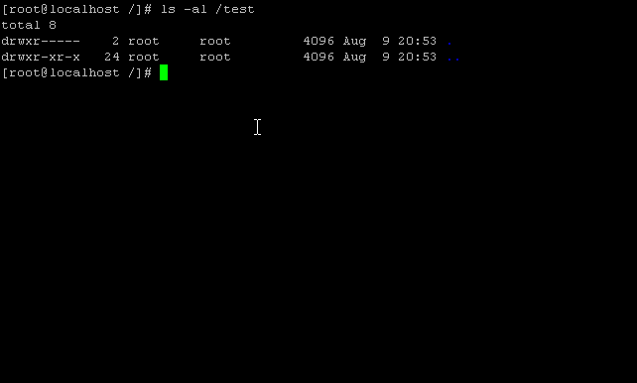
Figure 3 - Directory Listing after the Change

- We can test out these ACLs by logging in as another user. If you do not have another account on this host, use the following two commands to create a user called student and to assign that user a password:
useradd student
passwd student
- Change to the student account with the following command:
su student
- Attempt to change to the /test directory with the following command (you will be denied and the output should look like that in Figure 4).
cd /test

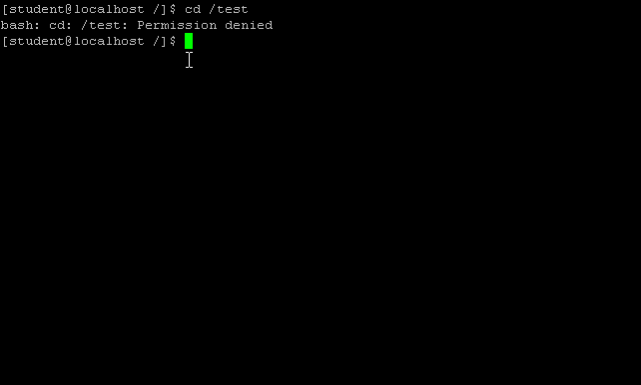
Figure 4 - Unsuccessful Directory Listing

- To get back to the root user shell, type exit.
- Change the permissions of the /test directory to allow world access with the following command:
chmod 755 /test
- Change to the student account again (su student).
- List the contents of the /test directory with the following command (it will now be successful and look like the output shown in Look at the output from the ethereal capture, which should be similar to that in Figure 5:
ls –al /test

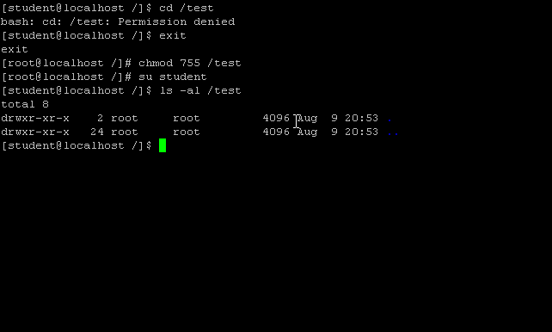
Figure 5 - Successful Directory Listing

